Malley's Fundraiser
We are once again selling Malley’s Chocolate Bars.

Each box contains 36 candy bars and should be sold for $1.50 each. There is a limit of 2 boxes out at a time. In past years, FOVM sold over 11,000 candy bars so in order to help us keep better records we are requiring that when you turn in money it must have a piece of paper that has the student name that the money is going towards and the amount of money being turned in. You will turn in $54 per box. Students will earn $16 per box sold.

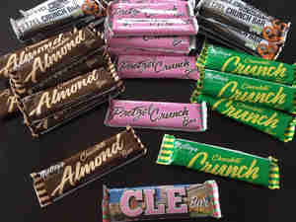
You can choice a mix box which will include five different flavors or choose a box of one flavor.
Please text Kelly Rose @ (216) 407-1773 with order requests or questions.

